A note about this service:

We are grateful to the Rev. Karl Heimbuck (pastor of First Presbyterian Church, Sheridan, Wyoming) for the creation of this service.

The goal of this resource is to free CAMP participants from the labors of planning for (and hopefully leading) worship for the Sunday before or after CAMP, in hopes that you will be able to arrive un-harried (or, at least, less so).

Notes:
- All liturgy is built thematically from “The Peace of Wild Things” by Wendell Berry. The poem may be read at the beginning of the service as a centering piece for reference. Hear the poet read it here.
- There is no sermon. This service can easily be led by lay leadership. The “proclamation of the word” portion of the service is a service of Lessons and Carols. The sequence is built from a passage of Job and the Accra Confession, with hymns selected to reflect the theme of the preceding liturgy and an overall emphasis on the call of Christians to care for God’s creation.
- Font Explanation
  - Text which appears in italics and bold is intended to be printed in the bulletin.
    - Italics — One voice/leader
    - Bold — Many/corporate
  - Plain text — Leader parts, which may be printed or not printed based upon your practices

- Hymns/Music
  - Recommendations for hymns and music from the Presbyterian Hymnal and Glory to God are included
  - The following contemporary music options could be substituted throughout the service
    - “The Earth is Yours” – Gungor (CCLI – 5665655)
    - “Still Water” — Rend Collective (CCLI – 7260198)
    - “God of Wonders” — (CCLI 3118757)
    - “All Creatures of Our God and King” — (CCLI 3608102)
    - “Indescribable” — (CCLI 4403076)
    - “Psalm 150 (Praise the Lord)” — CCLI 7161130)

- Credit: Please credit the service in your bulletin using the following text — This service was crafted by the Rev. Karl Heimbuck and the Rev. Shelli Latham and provided by the Omaha Presbyterian Seminary Foundation (OPSF). Learn more about OPSF and their mission to support congregational leaders at opsf-omaha.org.
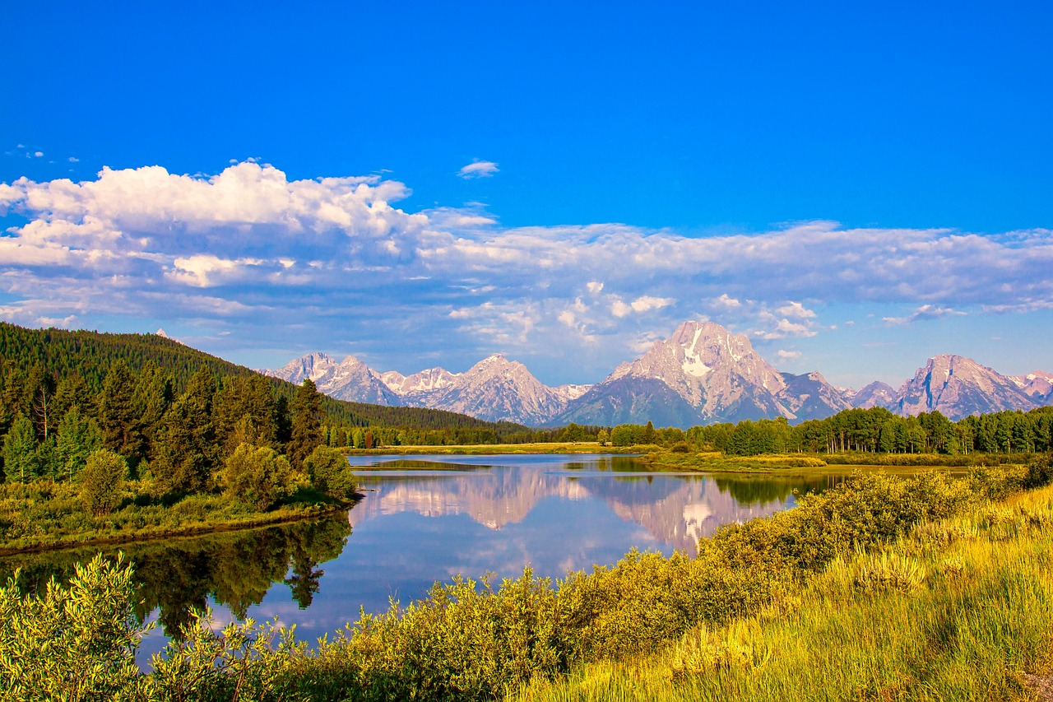

LET US WORSHIP GOD

The Peace of Wild Things — Wendell Berry
When despair for the world grows in me
and I wake in the night at the least sound
in fear of what my life and my children’s lives may be,
I go and lie down where the wood drake
rests in his beauty on the water, and the great heron feeds.
I come into the peace of wild things
who do not tax their lives with forethought
of grief. I come into the presence of still water.
And I feel above me the day-blind stars
waiting with their light. For a time
I rest in the grace of the world, and am free.

Poem: Counterpoint Press, 2012 by Wendell Berry. First published in Openings: Poems (1968); reprinted in Collected Poems, 1957-1982

Image: Grand Teton Mountains, Mohan Nannapaneni (pixabay.com/users/mohann-8137807)
GATHERING

Gathering Words/Call to Worship

One: There is a place where each bird’s beauty
Many: shimmers upon waters that give rest and food.
There is a place where tomorrow’s burdens
bear no weight upon the possibilities of today.
There is a place where still waters
are ready to nourish parched hearts.
There is a place where God’s peace
seeks our lying down.
There is a place
and that place is God’s creation.
There is a place
and that place is here.

Opening Hymn — “All Creatures of Our God and King” (Verses 1&2 – PH 455, GTG 15)

Call to Confession

While despair and fear can be valid parts of the human experience, we too often lose today in the past’s despair and fear for our future. God desires for us to find the peace and mercy of Christ right now so that all we imagine going forward can be grounded in grace and its dreams for justice. Let us open our hearts to this mercy in prayer.

Prayer of Confession

Creating God, you made the wild spaces of forests and oceans, mountains and plains. You made our own hearts. Creation sings your praise with its every breath. Trees sway to the melody of your breeze. Waves crash and roll in the power of your pull. We are not so faithful. Rather than join creation’s praise, we silence it. We lay waste to the work of your hands in hopes that our hands will have too much to hold. Have mercy upon us. By your Spirit, guide our wild hearts back to you that they may become wilderness spaces for rest and delight, not spaces torn apart for false gain. Amen.

Assurance of Grace

The grace and mercy of Jesus Christ is like a day-blind star, present even when we cannot see it, always waiting with light. Let us declare this good news together:

In Jesus Christ, we are forgiven. Thanks be to God!

Sharing the Peace of Christ

As those who have received the peace of Christ, let us take a moment to share that with one another.

The peace of Christ be with you. And also with you.

Response of Praise — “All Creatures of Our God and King” (Verses 3&4 – PH 455, GTG 15)

WORD
A Service of Lessons and Carols

Children’s Message (Note: This may easily be adapted to an intergenerational message. If using this piece, the introduction to the scripture may be removed or truncated below.)

Focus of the message: God is an unbelievably amazing creator! If God has the power over so many amazing things, God is in control even in the worst times.

Pre-worship prep: Choose facts or pictures about nature which seem unbelievable. All facts should be true.
- Links to pictures
- Bizarre Animals (probably skip the Echidnas ) — Other seemingly unreal animals might include – Okapi, Narwal, Red Panda
- Natural Wonders — You might also consider Natural Wonders or pictures of National Parks
- Links to Facts About Nature
  - Random Facts about Nature
  - Random Facts about Animals
  - Printable Facts Sheet with Pictures
  - Amazing Facts about Natural Wonders

- Introduce the game: Believable or Unbelievable

Today, we will play a game called “Believable or Unbelievable.” I will show/tell you something about nature, and you will have to tell me whether it is true (believable) or untrue (unbelievable). Again if you think the fact/picture is a real thing, you will shout out “believable” and if you think it is made up, you will shout out “unbelievable.”

- Play: Believable or Unbelievable — Play several rapid-fire rounds, offering quick explanations of why something is true, as needed. Don’t worry if it is chaotic with people being slightly perplexed about the seemingly unbelievable things actually being true.

- Connect to the Scripture

In our scripture for today, we will hear God talking to Job. It’s part of God’s test of Job about God’s power in the world. Job’s life seems to be falling apart, and lots of bad things are happening to him and those he loves, and God is reminding Job who (God) has the awesome power to handle the great and terrible stuff.

We’re going to hear God ask Job a bunch of amazing things about who made and controls creation. It’s like a game of “Believable or Unbelievable.” And the answer is always that God did these true but almost unbelievable things: like building the earth from scratch and putting stars in the sky in just the right pattern, and knowing every time a mama goat is going to have her babies.

If God can really, truly do these “unbelievable” things, God can take care of Job and all the tough things happening in his life. And God uses that same power and love for everything God creates to take care of us too — that is believable!

- Pray — Use the Prayer for Illumination from below to launch from the Children’s message into the Lessons and Carols.

Introduction to the Lessons and Carols (This section may be printed in worship notes or spoken aloud. Note that if you are using the Children’s Message, you will not need to do as much explanation of the scripture.)

Introduction to the Lessons and Carols

Today’s worship service is crafted in the style of lessons and carols. The service is structured around scripture from Job 38-42 and the Accra Confession.

Introduction to the Scripture (selected portions of Job 38:1-42-2
Job’s world has come crashing down. Back in Chapter 2, Job’s patience in suffering screeched to a halt, with Job challenging God to account for Job’s suffering and for the injustice he witnessed across all of creation. Job 38 marks the beginning of God’s response. Today’s passages come from two divine speeches. The form of the speeches is a barrage of rhetorical questions (pretty sassy ones sometimes) intended to highlight Job’s lack of understanding of God’s authority and intimate relationship with the world. They have been adapted slightly for readability in worship.

Introduction to the Accra Confession

In 1989, the World Alliance of Reformed Churches (the WARC) met in Seoul, Korea and were called upon to covenant together to seek a faithful response to “threats to life in our age, for the sake of the whole creation, the future of all humanity and especially for the children and young people of the planet.”

For more than a decade, global partners in this organization evaluated threats, considered faithful action, and worked to commit to a process of education and confession regarding ecological destruction and its correlating economic injustices.

In 2004, with increasing calls from the WARC partners in the global South who bear the brunt of creation’s harm and unjust economic practices, the WARC gathered in Accra, Ghana and came to a consensus regarding the problematic nature of the global economy and the havoc it wreaks upon both creation and the poor. While the document was not a doctrinal confessional stance, the assembly produced the Accra Confession, a response in our Reformed and confessional heritage, to take a faithful stance regarding all God has entrusted to us to steward: the care of the most vulnerable among us and the beauty of the earth.

Today, we echo these words in liturgy and song to remember the ancient call to touch the earth lightly so that all may know God’s blessings.
Prayer for Illumination

Dear God, our unbelievable creator, we are surrounded by the awesomeness of all that you have made. You made the light that guides our paths and warms our bodies and spirits out of nothing. How unbelievable is that?! As we explore your presence in the world and in our lives, shine your light that we may understand your Word for us. Show us your power and creativity in fresh ways, so that we may find new hope and live more faithfully for you. Amen.

Hymn — “For the Beauty of the Earth” (PH 473, GTG 14)

Scripture Reading One — Job 38:1-15 (adapted from CEB version)

Then the Lord answered Job from the whirlwind:

Where were you when I laid the earth’s foundations?
Who set its measurements?
Who stretched a measuring tape on it?
On what were its footings sunk;
who laid its cornerstone,
while the morning stars sang in unison
and all the divine beings shouted?
Who enclosed the Sea behind doors
when it burst forth from the womb,
when I made the clouds its garment,
the dense clouds its wrap,
when I imposed my limit for it,
put on a bar and doors
and said, “You may come this far, no farther;
here your proud waves stop”?
In your lifetime have you commanded the morning,
informed the dawn of its place
so it would take hold of earth by its edges
and shake the sin right out of it?
Do you turn it over like clay for a seal,
so it stands out like a colorful garment?

Confession One — Accra Confession 5 & 6 (adapted last line)

We have heard that creation continues to groan, in bondage, waiting for its
liberation (Rom 8.22). We are challenged by the cries of the people who suffer and by the woundedness of creation itself. We see a dramatic convergence between the suffering of the people and the damage done to the rest of creation.

The care of the earth is a matter of life and death.

Hymn (choose one from the following):

“Thank You, God, for Water, Soil, and Air” (PH 266)
“All Things Bright and Beautiful” (PH 267, GTG 20)
“For the Fruit of All Creation” (GTG 36)
“Touch the Earth Lightly” (GTG 713)

Scripture Reading Two — Job 38:16-20,25-35 (adapted from the CEB version)

Have you gone to the sea’s sources,
walked in the chamber of the deep?
Have you surveyed earth’s expanses?
Tell me if you know everything about it.
Where’s the road to the place where light dwells;
darkness, where’s it located?
Can you take it to its territory;
do you know the paths to its house?
Who cut a channel for the downpours
and a way for blasts of thunder
to bring water to uninhabited land,
a desert with no human
to saturate dry wasteland
and make grass sprout?
From whose belly does ice come;
who gave birth to heaven’s frost?
Water hardens like stone;
the surface of the deep thickens.
Can you bind Pleiades’ chains
or loosen the reins of Orion?
Can you guide the stars
at their proper times,
lead the Bear with her cubs?
Do you know heaven’s laws,
or can you impose its rule on earth?
Can you issue an order to the clouds
so their abundant waters cover you?
Can you send lightning so that it goes
and then says to you, “I’m here”?
Confession Two — Accra Confession 17

We believe in God, Creator and Sustainer of all life, who calls us as partners in the creation and redemption of the world. We live under the promise that Jesus Christ came so that all might have life in fullness (Jn 10.10).

Guided and upheld by the Holy Spirit we open ourselves to the reality of our world.

Hymn — “Called as Partners in Christ’s Service” (PH 343, GTG 761)

Reading Three — Job 38:36-41, 39:1-8, 26-30, 42:1-2 (adapted from The Message)

Who do you think gave weather-wisdom to the heron,
and storm-savvy to the rooster?
Does anyone know enough to number all the clouds
or tip over the rain barrels of heaven
When the earth is cracked and dry,
the ground baked hard as a brick?

Can you teach the lioness to stalk her prey
and satisfy the appetite of her cubs
As they crouch in their den,
waiting hungrily in their cave?
And who sets out food for the ravens
when their young cry to God,
fluttering about because they have no food?”

Do you know the month when mountain goats give birth?
Have you ever watched a doe bear her fawn?
Do you know how many months she is pregnant?
Do you know the season of her delivery?
Who do you think set the wild donkey free,
opened the corral gates and let him go?
I gave him the whole wilderness to roam in,
the rolling plains and wide-open places.
He grazes freely through the hills,
nibbling anything that’s green.

Was it through your know-how that the hawk learned to fly,
soaring effortlessly on thermal updrafts?
Did you command the eagle’s flight,
and teach her to build her nest in the heights,
Perfectly at home on the high cliff face,
invulnerable on pinnacle and crag?
. . .
Job answered God:

I’m convinced: You can do anything and everything.
Nothing and no one can upset your plans.”

Confession Three — Accra Confession 20 & 22

We believe that God has made a covenant with all of creation (Gen 9.8-12). God has brought into being an earth community based on the vision of justice and peace. The covenant is a gift of grace that is not for sale in the marketplace (Is 55.1). It is an economy of grace for the household of all of creation.

We believe that any economy of the household of life given to us by God’s covenant to sustain life is accountable to God. We believe the economy exists to serve the dignity and wellbeing of people in community, within the bounds of the sustainability of creation. We believe that human beings are called to choose God over Mammon and that confessing our faith is an act of obedience.

Hymn (Choose one of the following. Note: If you will include a collection of offering and are tight on time, you could move the Invitation to Share our Gifts up and consolidate this hymn with the offertory below.):

“This Is My Father’s World” (PH 293, GTG 370)
“We Wait the Peaceful Kingdom” (GTG 378)
“Touch the Earth Lightly” (GTG 713, if not used earlier)

RESPONDING TO THE WORD

Prayers of the People

Let us pray.

Creative God,
your hands have wrought the wonders of the world,
setting places for work and rest,
summons to follow in the way of Christ’s justice,
invitations to lie down in sabbath even before despair reaches its peak.

We give you our thanks for this creation,
for meandering streams in the mountains,
ponds upon the prairies,
and all the still waters that offer peace.

We give you thanks for rushing rivers,
wave-filled oceans,
falling waters,
the movements of creation that bring us toward one another.
As these waters usher goods and people around the world,
may their flowing movements shape our imaginations
for a justice that is just as powerful.

God, we look at your creation,
and know your beauty and desire for good.
By your same hands that made the world,
bring peace to corners of the globe in turmoil,
healing to hearts that have been torn apart,
accompaniment to all who are alone,
and courage to those making a way out of no way.

Loving One, do not stop creating,
and where our hands can help
and join in your creative power,
by your Holy Spirit,
show us how.

We pray this in the name of Jesus Christ,
Redeemer of all creation. Amen.

The Lord’s Prayer (You might consider the version from the First Nations Version of the New Testament.)

O Great Spirit, our Father from above,
we honor your name as sacred and holy.
Bring your good road to us,
where the beauty of your ways in the spirit-world above
is reflected in the earth below.
Provide for us day by day–
the elk, the buffalo, and the salmon.
The corn, the squash, and the wild rice.
All the things we need for each day.
Release us from the things we have done wrong,
in the same way we release others for the things done wrong to us.
Guide us away from the things that tempt us to stray from your good road,
and set us free from the evil one and his worthless ways.
Aho! May it be so!

Invitation to Share our Gifts

Family of God, the earth is the Lord’s and everything in it. In gratitude for God’s abundant provision . . . In thanksgiving for God’s inconceivable creativity . . . and in awe of God’s entrusting of us to nurture the expansive beauty all around us, let us pause to set aside a portion of our time, talent, and treasure for the furthering of God’s dreams.

Offertory/Anthem (Consider using one of the unused hymns noted in this service or anthem options below. There are some beautiful audio recordings of both listed anthems. Please, verify that you have permission to play the audio and consider purchasing the recording.)

“A Gaelic Blessing (Deep Peace),” by John Rutter
“The Peace of Wild Things,” text Wendell Berry, music Jake Runestad

Doxology — “All Creatures of Our God and King” (Verse 6 – PH 455, GTG 15)

Prayer of Dedication

Generous Creator, since the beginning you have blessed us with a creation whose beauty inspires wonder and reveals the graces of your own heart. May the gifts we return in thanksgiving uphold this beauty from devastation and preserve the wild spaces where the peace of Christ and solace of the Spirit are so often found. Amen.

SENDING
Charge & Benediction [from “A Gaelic Blessing (Deep Peace), by John Rutter, inspired by William Sharp’s novel (1895) The Dominion of Dreams: Under the Dark Star]

Deep peace of the running wave to you
Deep peace of the flowing air to you
Deep peace of the quiet earth to you
Deep peace of the shining stars to you
Deep peace of the gentle night to you
Moon and stars pour their healing light on you
Deep peace of Christ the light of the world to you
Deep peace of Christ to you

Family of God, hand crafted by the most unbelievable creator,
May you go in peace
into a world knit together with love and hope
a world crying out to you: come and rest in me
a world crying out: may I rest in you
Go in peace
to love and serve the Lord. Amen.

Fun fact: “ A Gaelic Blessing (Deep Peace)” was commissioned by the Chancel Choir of the First United Methodist Church in Omaha, Nebraska in 1978.

