Retreat for Single Pastors

Pastors from Nebraska, Iowa and Missouri gathered at the Downtown Omaha Embassy Suites Hotel, August 2-5, 2020, for a retreat focusing on Becoming Yourself. Suzanne Gorhau and Kathy Noble of Come Away, My Beloved (http://comeawaymybeloved.org/) lead workshops on prayer, writing one’s one manifesto and unique ways of discovering oneself. One participant noted that “prayer by coloring was a great discovery that allowed me to focus and hold and care for my prayer subjects in a tangible way.” Sara Tonje was the worship leader for the gathering.

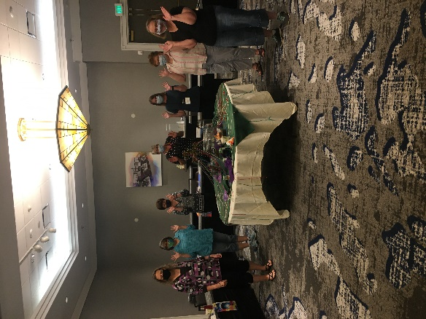
This was the first retreat held by PLR since the pandemic started. The hotel had excellent safety protocols in place. The participants all wore masks. A mask contest was held one night for most colorful mask, funniest mask, and most Presbyterian mask.
The participants were grateful that the retreat was held. One single pastor said, “It was excellent to BE WITH and learn/grow in community.” Another said that what she most appreciated was being with peers in similar situations, i.e., single and divorced women.
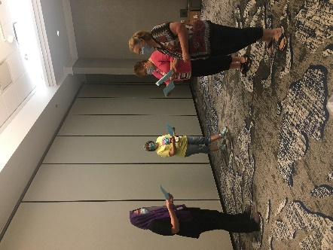
A meaningful part of worship was using a sharpie and writing on a stone one word that represented baggage for the worshippers. Sara Tonje then invited the worshipers to take the rock somewhere outside and throw it, as a way to release the baggage. Later, several participants noted how freeing that was. Sara also invited several participants to do a Reader’s Theater of the Exodus story of the midwives, Shiphrah and Puah – that we know their names, but not the name of the ‘powerful’ Pharaoh.
Suzanne and Kathy gave all the participants blank Traveler’s Journal, as well as a whole bunch of 2”x3” pictures with scripture passages. The participants kept notes, drawings and added the pictures to their journals to personalize them, and remember key aspects of the retreat.
The retreat demonstrated that it’s possible to gather safely in person and be the people of God. All participants felt comfortable with the safety protocols of both the hotel and OPSF.
